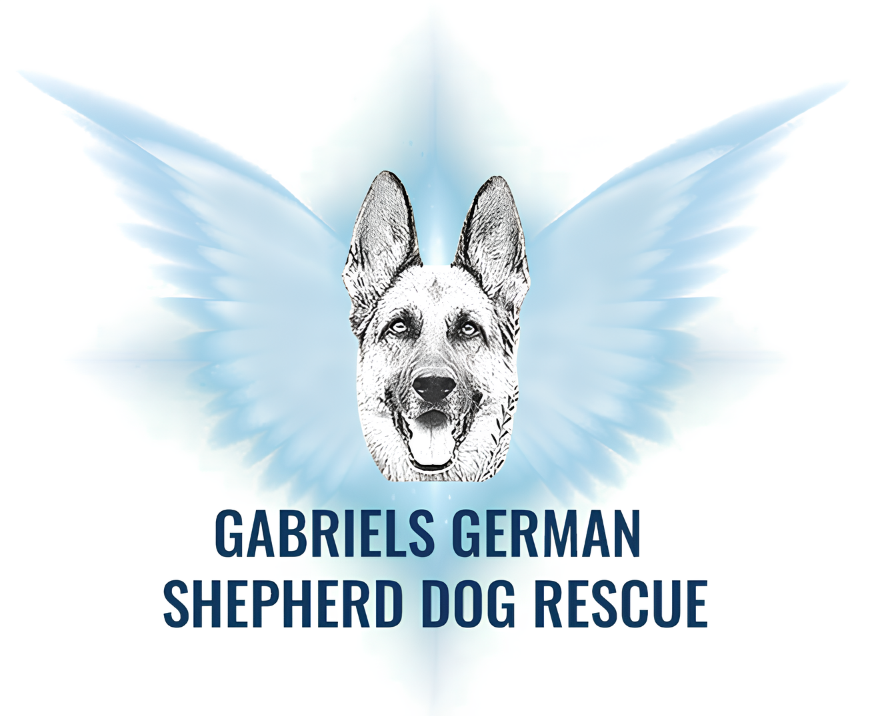
GGSDR

WILMINGTON, DE
Tele: 302 517 2100
–Adoption Contract-

I, __ ______________________________, do this ______day of__ _____, 20____, enter into this Adoption Contract for _______________ the dog described as: __________(Breed),________ (Age) ______ _ (Weight) . Description Contribution fee: $__300.00____.

The adoption fee includes the following.

Shelter Fees if any, Initial Vet exam – basic shots (age appropriate in puppies),
de-worming, flea treatment and other anti-parasite treatment as necessary, Spay/neuter, OTHER:____________________________________________________

GGSDR provides medical records and history of the dogs if known.

The Adopter agrees: from the adoption date to:
- PROIVISION OF CARE. The adopter assumes
full responsibility for the veterinary care of this dog and will provide this dog with necessary veterinary care upon sickness, disease and/or injury. will take him or her to the veterinarian at least once a year for an examination and routine vaccinations and tests or more often if necessary.
- HUMANE CONDITIONS. provide this dog with humane home care as a family pet in accordance with all laws and standards. The adopter will provide this dog with a fully fenced yard or other humane means of dally exercise. He or she shall not be kept outside in a yard, or constantly chained or tied outside.

- DOG IS PET. This dog will reside in adopter’s home, will be kept as a household pet, and will not be used for breeding, or exclusively as a hunting or guard dog. PLEASE INITIAL THIS CLAUSE_________

- SUPERVISION. The dog will not be left unsupervised with other pets or children for the first few months after adoption.
- ABUSE/NEGLECT. The adopter agrees not to abuse or neglect the dog and also authorizes GGSDR, in its discretion, to determine whether or not the dog has been abused/neglected. The adopter will not physically punish the dog. The adopter will consult with GGSDR, their veterinarian and or any trainer about the appropriate ways of dealing with specific behavioral problems.

- LIMIT EUTHANASIA. The adopter will only euthanize the dog for an untreatable, fatal medical condition, as attested to by a licensed veterinarian and will notify GGSDR.

- RETURN. If, for any reason, the adopter cannot keep this dog, the adopter will notify GGSDR and hold the dog keeping the dog healthy and safe, provide pictures and information to post for re-adoption and fully work support a new adopter or a foster home. The adopter will return the dog to GGSDR. The dog will not be given away, surrendered, sold, or exchanged. If any friend/family member who wishes to take ownership of this dog will be required to apply to GGSDR. PLEASE INITIAL THIS CLAUSE. _________
8. RELEASE. The adopter agrees, from the date of adoption, to release and indemnify GGSDR from any and all claims, known or unknown, now or hereafter arising in connection with this dog.
- EXAMINATION. The adopter consents to the examination of this dog by GGSDR at any time and acknowledges GGSDR can reclaim the dog at any time for failure to comply with the terms of this contract or for any misrepresentations of fact made on the adoption application or in this contract.
10. INDEMNIFY. The adopter agrees to pay GGSDR for any and all expenses, including court costs and attorney’s fees, if legal action is necessary to enforce the terms of this contract.
11. The adopter understands that the Adoption Fee is non-refundable.

- The adopter understands this is a legal and binding contract and by the signature below agrees to all of the terms.
Adopter Signature:__________________________________________________

Driver’s License No.________________________________________________Exp:
Adopter Name (Printed):___________________________________________________

GABRIELS GERMAN SHEPHERD DOG RESCUE Representative: __________________________________

Date: ________________

